Report Compiler Lab

Screen of execution of example2.kpl

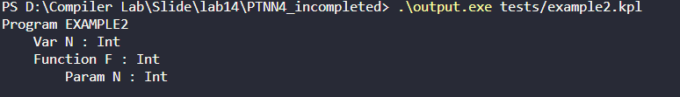

Modify example2.kpl to cause the error: "Type inconsistency" :

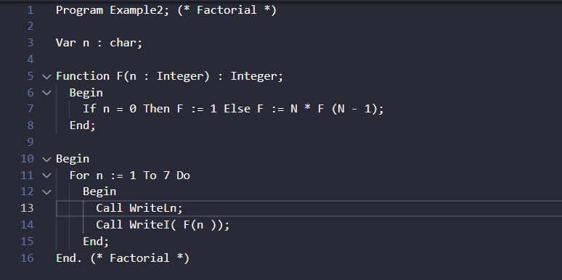



Modify example2.kpl to cause the error: "The number of arguments and the number of parameters are inconsistent."

